**EE101 Homework 5**

**Submit: Blackboard/Paper Due: Dec. 22th**

**Please write down Your Name & Student ID**

1. At room temperature (298K), if 1ml water is placed in a magnetic field whose strength is 4.7 Tesla, then what is the protons’ magnetization $M_{0}$ of that 1ml water?
2. Calculate the effects of the following pulse sequences on thermal equilibrium magnetization. The final answer should include x-, y-, and z-components of magnetization.

a) 90°x (a pulse with tip angle 90°, applied about the x-axis).

b) 30°y

c) 90°x 90°y (the second 90° pulse is applied immediately after the first).



*Fig2: Example of the magnetization after a 90°x pulse sequence*

1. The operator wishes to acquire an oblique slice shown by the orientation of the white bar in Figure 3. Draw the gradient echo imaging sequence that would be run to acquire such an image.



*Figure 3: The required oblique slice is shown by the white bar. The brain image is in sagittal orientation.*

1. Write an expression for the ${\text{M}}_{\text{z}}$ magnetization as a function of time after a 180° pulse. After what time is the ${\text{M}}_{\text{z}}$ component zero? Plot the magnetization $M_{z}$ after instead applying a 120° pulse.
2. Choose the correct option from (a)-(e) and *explain* why this is your choice.

The maximum MR signal is obtained by using:

(a) $45°$ RF pulse, long TE, and short TR;

(b) $45°$ RF pulse, short TE, and long TR;

(c) $90°$ RF pulse, short TE, and short TR;

(d) $90°$ RF pulse, long TE, and short TR;

(e) $90°$ RF pulse, short TE, and long TR.

1. Three images are shown in Figure 6: the scaling in each image is different and is normalized to the same maximum value. The imaging parameters are TR = 2000 ms, TE = 20 ms for one image, TR = 750 ms, TE = 80 ms for another, and TR = 2000 ms, TE = 80 ms for the final one.

(i) Assign each image to the appropriate TR and TE values.

(ii) Based on your answer, do the ventricles have a higher or lower T1 value than brain tissue? What is the corresponding answer for T2?



*Figure 6: Three brain images with different signal-to-noise ratios*

1. There is an MRI machine whose magnetic field has strength of 1.5T. Provided that the gyromagnetic ratio is $\frac{γ}{2π}=42.6MHz*T^{-1}$ and 1T = ${10}^{4}$ Gauss.
2. Assume the gradient along z direction is 1 Gauss·· ${cm}^{-1}$. To get a slice image of thickness 10mm, what should the bandwidth of the RF pulse be?
3. If the gradient becomes 2 Gauss·· ${cm}^{-1}$, and the bandwidth of the RF pulse remains unchanged, then what will the slice thickness become?
4. Consider the pulse sequence in Figure 8 (surface 2 equals two times surface 1). Draw the trajectory of k in the k-space.



*Figure 8*

1. Design an EPI pulse sequence that gives the square spiral k-space trajectory shown in Figure 9.

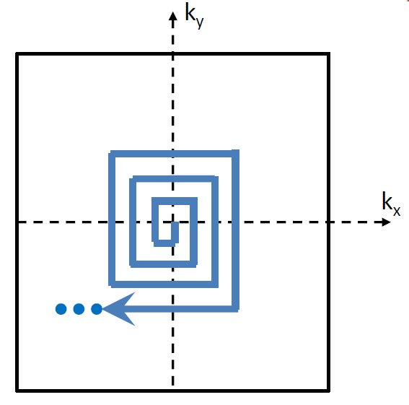

Figure 9